

Search Medium

[Write](https://medium.com/m/signin?operation=register&redirect=https%3A%2F%2Fmedium.com%2Fnew-story&source=---two_column_layout_nav-----------------------new_post_topnav-----------)

Sign up

[Sign In](https://medium.com/m/signin?operation=login&redirect=https%3A%2F%2Fmedium.com%2F%40mayomi1%2Fhow-to-host-a-node-js-app-on-shared-host-52e12a62a259&source=post_page---two_column_layout_nav-----------------------global_nav-----------)

https://miro.medium.com/v2/resize:fill:32:32/1*dmbNkD5D-u45r44go_cf0g.png

Top highlight

**How to host a Node.js app on shared host**

[[Mayomi Ayandiran](https://medium.com/@mayomi1?source=post_page-----52e12a62a259--------------------------------)](https://medium.com/@mayomi1?source=post_page-----52e12a62a259--------------------------------)

[Mayomi Ayandiran](https://medium.com/@mayomi1?source=post_page-----52e12a62a259--------------------------------)

·

[Follow](https://medium.com/m/signin?actionUrl=https%3A%2F%2Fmedium.com%2F_%2Fsubscribe%2Fuser%2F813543697afb&operation=register&redirect=https%3A%2F%2Fmedium.com%2F%40mayomi1%2Fhow-to-host-a-node-js-app-on-shared-host-52e12a62a259&user=Mayomi+Ayandiran&userId=813543697afb&source=post_page-813543697afb----52e12a62a259---------------------post_header-----------)

3 min read

·

Mar 26, 2018

1.6K

32



image from <http://bloggersclan.com/what-is-shared-web-hosting/>

Hi guys, have you ever wanted to host your Node.js application on a shared hosting server and you are having issues with hosting it, you might have even done a lot of google search on how to host it, well with this article we will fix this issue together as will move on in this article.

Most Shared Hosting company normally have PHP preinstalled on your server, the first thing to do is to install NVM on your server. To do this you will need access to login with SSH from your terminal(Command line). To have access to SSH of your server ask your host provider.

ssh -p port username@IpAddress

when it asks for your password, enter the password you normally to login to your Cpanel. With this, you are done with the first step.

**Step two: Installing the NVM on your Server.**  
If you have been able to successfully login through ssh, you can now do and undo. The ssh access let you have access to all lovely Linux commands.  
Now run this to add NVM install

Run this first

wget -qO- https://cdn.rawgit.com/creationix/nvm/master/install.sh | bash

then run this

nvm install stable

Step four:  
After the installation has been completed, close and reopen the terminal where you are running the ssh, login again the same way you logged in the first time.  
run

node -vnpm -vTo confirm that node and npm has been successfully installed.

Now create a .htaccess file inside the public_html directory on your server. To do this,

cd ~/public_htmlnano .htaccess

after that copy the below into in the file

RewriteEngine On  
RewriteRule ^$ http://127.0.0.1:XXXXX/ [P,L]  
RewriteCond %{REQUEST_FILENAME} !-f  
RewriteCond %{REQUEST_FILENAME} !-d  
RewriteRule ^(.*)$ http://127.0.0.1:XXXXX/$1 [P,L]

N:B Replace the XXXXX with the port you set in your app.

*I assumed you already have uploaded your application to the public_html on your server.*

Step Five:

If you have already uploaded your project to the server already you can run the app the same way you normally do on your local server,

node app.js or node server.js, just run it the way you would do it locally

Step Six:

If you reload the website with your domain name, you should load the page correctly by now, but it you press control C on the terminal, i.e if you kill the server you page will not render again. This is perfectly normal, it mean we need a way to make sure our server continue to run after we exit the terminal, you can just do :

node app.js &

it will keep running even after you exist the terminal , but if you want a more efficient way of doing this, you can install a package that take care of that

npm install -g forever

than start the server.

forever start app.js

And now you have successfully hosted your node.js application on shared host.



celebration time

[Nodejs](https://medium.com/tag/nodejs?source=post_page-----52e12a62a259---------------nodejs-----------------)

[Servers](https://medium.com/tag/servers?source=post_page-----52e12a62a259---------------servers-----------------)

[Shared Hosting](https://medium.com/tag/shared-hosting?source=post_page-----52e12a62a259---------------shared_hosting-----------------)

[Web Development](https://medium.com/tag/web-development?source=post_page-----52e12a62a259---------------web_development-----------------)

[DevOps](https://medium.com/tag/devops?source=post_page-----52e12a62a259---------------devops-----------------)

1.6K

32

[[Mayomi Ayandiran](https://medium.com/@mayomi1?source=post_page-----52e12a62a259--------------------------------)](https://medium.com/@mayomi1?source=post_page-----52e12a62a259--------------------------------)

[Written by Mayomi Ayandiran](https://medium.com/@mayomi1?source=post_page-----52e12a62a259--------------------------------)

[227 Followers](https://medium.com/@mayomi1/followers?source=post_page-----52e12a62a259--------------------------------)

Software Engineer - web3 enthusiast

Follow

More from Mayomi Ayandiran

[[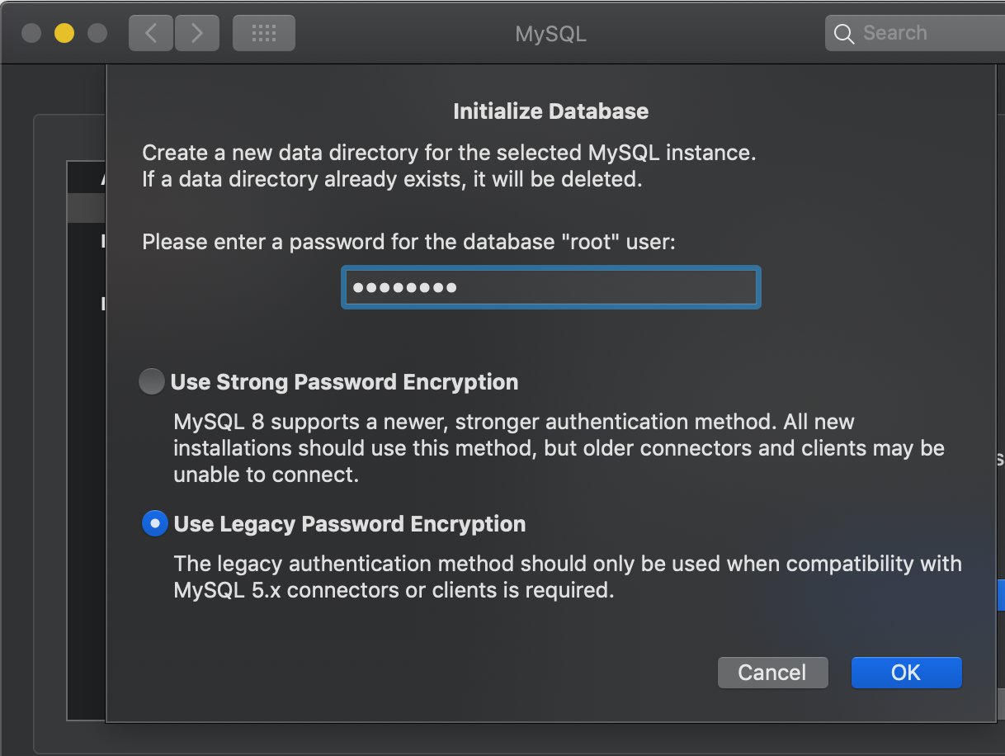](https://medium.com/@mayomi1/how-to-fix-error-1045-28000-access-denied-for-user-root-localhost-using-password-yes-on-854294790970?source=author_recirc-----52e12a62a259----0---------------------f6822405_f290_4d75_95ba_979daf80ce6d-------)](https://medium.com/@mayomi1/how-to-fix-error-1045-28000-access-denied-for-user-root-localhost-using-password-yes-on-854294790970?source=author_recirc-----52e12a62a259----0---------------------f6822405_f290_4d75_95ba_979daf80ce6d-------)

[[Mayomi Ayandiran](https://medium.com/@mayomi1?source=author_recirc-----52e12a62a259----0---------------------f6822405_f290_4d75_95ba_979daf80ce6d-------)](https://medium.com/@mayomi1?source=author_recirc-----52e12a62a259----0---------------------f6822405_f290_4d75_95ba_979daf80ce6d-------)

[Mayomi Ayandiran](https://medium.com/@mayomi1?source=author_recirc-----52e12a62a259----0---------------------f6822405_f290_4d75_95ba_979daf80ce6d-------)

**[How to fix: ERROR 1045 (28000): Access denied for user ‘root’@’localhost’ (using password: YES) on…](https://medium.com/@mayomi1/how-to-fix-error-1045-28000-access-denied-for-user-root-localhost-using-password-yes-on-854294790970?source=author_recirc-----52e12a62a259----0---------------------f6822405_f290_4d75_95ba_979daf80ce6d-------)**

[something you get this error when you do](https://medium.com/@mayomi1/how-to-fix-error-1045-28000-access-denied-for-user-root-localhost-using-password-yes-on-854294790970?source=author_recirc-----52e12a62a259----0---------------------f6822405_f290_4d75_95ba_979daf80ce6d-------)

[1 min read·Nov 19, 2019](https://medium.com/@mayomi1/how-to-fix-error-1045-28000-access-denied-for-user-root-localhost-using-password-yes-on-854294790970?source=author_recirc-----52e12a62a259----0---------------------f6822405_f290_4d75_95ba_979daf80ce6d-------)

208

[4](https://medium.com/@mayomi1/how-to-fix-error-1045-28000-access-denied-for-user-root-localhost-using-password-yes-on-854294790970?responsesOpen=true&sortBy=REVERSE_CHRON&source=author_recirc-----52e12a62a259----0---------------------f6822405_f290_4d75_95ba_979daf80ce6d-------)

[[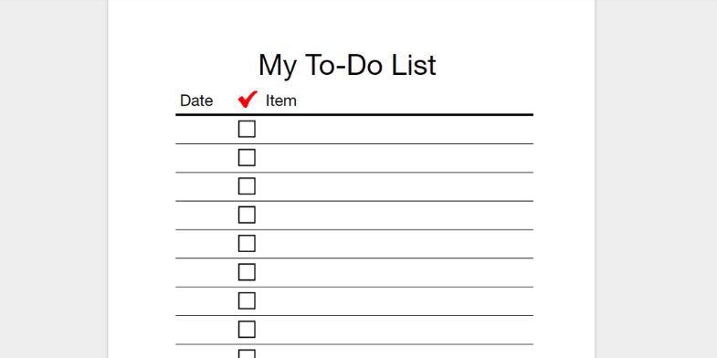](https://medium.com/devcenter/easy-way-to-php-todolist-app-crud-e1284265bb27?source=author_recirc-----52e12a62a259----1---------------------f6822405_f290_4d75_95ba_979daf80ce6d-------)](https://medium.com/devcenter/easy-way-to-php-todolist-app-crud-e1284265bb27?source=author_recirc-----52e12a62a259----1---------------------f6822405_f290_4d75_95ba_979daf80ce6d-------)

[[Mayomi Ayandiran](https://medium.com/@mayomi1?source=author_recirc-----52e12a62a259----1---------------------f6822405_f290_4d75_95ba_979daf80ce6d-------)](https://medium.com/@mayomi1?source=author_recirc-----52e12a62a259----1---------------------f6822405_f290_4d75_95ba_979daf80ce6d-------)

[Mayomi Ayandiran](https://medium.com/@mayomi1?source=author_recirc-----52e12a62a259----1---------------------f6822405_f290_4d75_95ba_979daf80ce6d-------)

in

[Devcenter Square Blog](https://medium.com/devcenter?source=author_recirc-----52e12a62a259----1---------------------f6822405_f290_4d75_95ba_979daf80ce6d-------)

**[Easy way to learn PHP: To-do list app(CRUD)](https://medium.com/devcenter/easy-way-to-php-todolist-app-crud-e1284265bb27?source=author_recirc-----52e12a62a259----1---------------------f6822405_f290_4d75_95ba_979daf80ce6d-------)**

[Episode #2](https://medium.com/devcenter/easy-way-to-php-todolist-app-crud-e1284265bb27?source=author_recirc-----52e12a62a259----1---------------------f6822405_f290_4d75_95ba_979daf80ce6d-------)

[10 min read·Sep 19, 2017](https://medium.com/devcenter/easy-way-to-php-todolist-app-crud-e1284265bb27?source=author_recirc-----52e12a62a259----1---------------------f6822405_f290_4d75_95ba_979daf80ce6d-------)

198

[5](https://medium.com/devcenter/easy-way-to-php-todolist-app-crud-e1284265bb27?responsesOpen=true&sortBy=REVERSE_CHRON&source=author_recirc-----52e12a62a259----1---------------------f6822405_f290_4d75_95ba_979daf80ce6d-------)

[[](https://medium.com/@mayomi1/easy-way-to-learn-php-the-beginning-5a60d600e3bd?source=author_recirc-----52e12a62a259----2---------------------f6822405_f290_4d75_95ba_979daf80ce6d-------)](https://medium.com/@mayomi1/easy-way-to-learn-php-the-beginning-5a60d600e3bd?source=author_recirc-----52e12a62a259----2---------------------f6822405_f290_4d75_95ba_979daf80ce6d-------)

[[Mayomi Ayandiran](https://medium.com/@mayomi1?source=author_recirc-----52e12a62a259----2---------------------f6822405_f290_4d75_95ba_979daf80ce6d-------)](https://medium.com/@mayomi1?source=author_recirc-----52e12a62a259----2---------------------f6822405_f290_4d75_95ba_979daf80ce6d-------)

[Mayomi Ayandiran](https://medium.com/@mayomi1?source=author_recirc-----52e12a62a259----2---------------------f6822405_f290_4d75_95ba_979daf80ce6d-------)

**[Easy way to learn PHP: The beginning](https://medium.com/@mayomi1/easy-way-to-learn-php-the-beginning-5a60d600e3bd?source=author_recirc-----52e12a62a259----2---------------------f6822405_f290_4d75_95ba_979daf80ce6d-------)**

[part 1](https://medium.com/@mayomi1/easy-way-to-learn-php-the-beginning-5a60d600e3bd?source=author_recirc-----52e12a62a259----2---------------------f6822405_f290_4d75_95ba_979daf80ce6d-------)

[5 min read·Sep 14, 2017](https://medium.com/@mayomi1/easy-way-to-learn-php-the-beginning-5a60d600e3bd?source=author_recirc-----52e12a62a259----2---------------------f6822405_f290_4d75_95ba_979daf80ce6d-------)

92

[[](https://medium.com/@mayomi1/the-solution-to-nigerians-election-conspiracy-decentralized-voting-system-de3512c2dcb9?source=author_recirc-----52e12a62a259----3---------------------f6822405_f290_4d75_95ba_979daf80ce6d-------)](https://medium.com/@mayomi1/the-solution-to-nigerians-election-conspiracy-decentralized-voting-system-de3512c2dcb9?source=author_recirc-----52e12a62a259----3---------------------f6822405_f290_4d75_95ba_979daf80ce6d-------)

[[Mayomi Ayandiran](https://medium.com/@mayomi1?source=author_recirc-----52e12a62a259----3---------------------f6822405_f290_4d75_95ba_979daf80ce6d-------)](https://medium.com/@mayomi1?source=author_recirc-----52e12a62a259----3---------------------f6822405_f290_4d75_95ba_979daf80ce6d-------)

[Mayomi Ayandiran](https://medium.com/@mayomi1?source=author_recirc-----52e12a62a259----3---------------------f6822405_f290_4d75_95ba_979daf80ce6d-------)

**[The solution to Nigerian’s election conspiracy — Decentralized voting system.](https://medium.com/@mayomi1/the-solution-to-nigerians-election-conspiracy-decentralized-voting-system-de3512c2dcb9?source=author_recirc-----52e12a62a259----3---------------------f6822405_f290_4d75_95ba_979daf80ce6d-------)**

[To make democracy work, we must be a nation of participants, not simply observers. One who does not vote has no right to complain. —…](https://medium.com/@mayomi1/the-solution-to-nigerians-election-conspiracy-decentralized-voting-system-de3512c2dcb9?source=author_recirc-----52e12a62a259----3---------------------f6822405_f290_4d75_95ba_979daf80ce6d-------)

[8 min read·Feb 1, 2018](https://medium.com/@mayomi1/the-solution-to-nigerians-election-conspiracy-decentralized-voting-system-de3512c2dcb9?source=author_recirc-----52e12a62a259----3---------------------f6822405_f290_4d75_95ba_979daf80ce6d-------)

804

[4](https://medium.com/@mayomi1/the-solution-to-nigerians-election-conspiracy-decentralized-voting-system-de3512c2dcb9?responsesOpen=true&sortBy=REVERSE_CHRON&source=author_recirc-----52e12a62a259----3---------------------f6822405_f290_4d75_95ba_979daf80ce6d-------)

[See all from Mayomi Ayandiran](https://medium.com/@mayomi1?source=post_page-----52e12a62a259--------------------------------)

Recommended from Medium

[[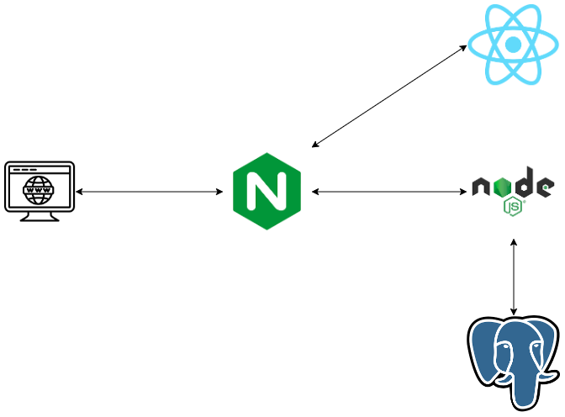](https://medium.com/@antonio.maccarini/dockerize-a-react-application-with-node-js-postgres-and-nginx-124c204029d4?source=read_next_recirc-----52e12a62a259----0---------------------3b6a993b_eb56_495d_9aad_f6b7fda8f160-------)](https://medium.com/@antonio.maccarini/dockerize-a-react-application-with-node-js-postgres-and-nginx-124c204029d4?source=read_next_recirc-----52e12a62a259----0---------------------3b6a993b_eb56_495d_9aad_f6b7fda8f160-------)

[[Antonio Maccarini](https://medium.com/@antonio.maccarini?source=read_next_recirc-----52e12a62a259----0---------------------3b6a993b_eb56_495d_9aad_f6b7fda8f160-------)](https://medium.com/@antonio.maccarini?source=read_next_recirc-----52e12a62a259----0---------------------3b6a993b_eb56_495d_9aad_f6b7fda8f160-------)

[Antonio Maccarini](https://medium.com/@antonio.maccarini?source=read_next_recirc-----52e12a62a259----0---------------------3b6a993b_eb56_495d_9aad_f6b7fda8f160-------)

**[Dockerize a React application with Node.js, Postgres and Nginx](https://medium.com/@antonio.maccarini/dockerize-a-react-application-with-node-js-postgres-and-nginx-124c204029d4?source=read_next_recirc-----52e12a62a259----0---------------------3b6a993b_eb56_495d_9aad_f6b7fda8f160-------)**

[This tutorial explains how to Dockerize a React application with Node.js, Postgres and Nginx. It provides step-by-step instructions on…](https://medium.com/@antonio.maccarini/dockerize-a-react-application-with-node-js-postgres-and-nginx-124c204029d4?source=read_next_recirc-----52e12a62a259----0---------------------3b6a993b_eb56_495d_9aad_f6b7fda8f160-------)

[11 min read·Jun 9](https://medium.com/@antonio.maccarini/dockerize-a-react-application-with-node-js-postgres-and-nginx-124c204029d4?source=read_next_recirc-----52e12a62a259----0---------------------3b6a993b_eb56_495d_9aad_f6b7fda8f160-------)

47

[[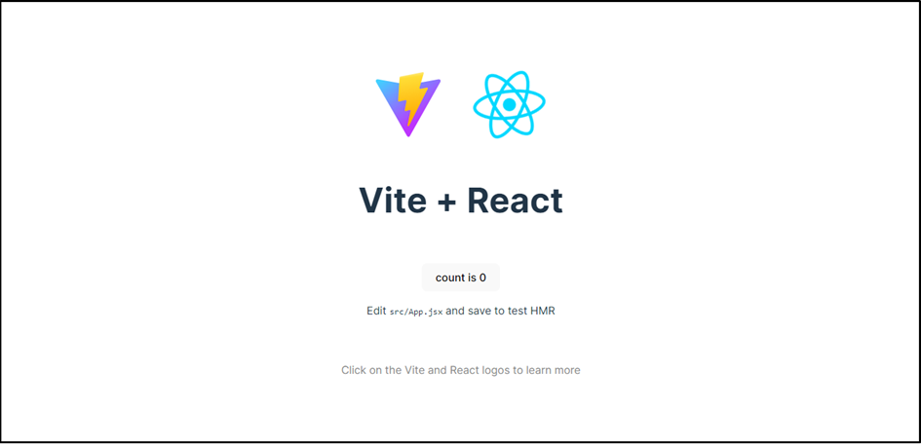](https://medium.com/@badreddine.boudaoud21/create-a-react-app-with-vite-and-deploy-it-on-github-48b82e19f821?source=read_next_recirc-----52e12a62a259----1---------------------3b6a993b_eb56_495d_9aad_f6b7fda8f160-------)](https://medium.com/@badreddine.boudaoud21/create-a-react-app-with-vite-and-deploy-it-on-github-48b82e19f821?source=read_next_recirc-----52e12a62a259----1---------------------3b6a993b_eb56_495d_9aad_f6b7fda8f160-------)

[[Badreddine Boudaoud](https://medium.com/@badreddine.boudaoud21?source=read_next_recirc-----52e12a62a259----1---------------------3b6a993b_eb56_495d_9aad_f6b7fda8f160-------)](https://medium.com/@badreddine.boudaoud21?source=read_next_recirc-----52e12a62a259----1---------------------3b6a993b_eb56_495d_9aad_f6b7fda8f160-------)

[Badreddine Boudaoud](https://medium.com/@badreddine.boudaoud21?source=read_next_recirc-----52e12a62a259----1---------------------3b6a993b_eb56_495d_9aad_f6b7fda8f160-------)

**[Create a React app with Vite and deploy it on GitHub](https://medium.com/@badreddine.boudaoud21/create-a-react-app-with-vite-and-deploy-it-on-github-48b82e19f821?source=read_next_recirc-----52e12a62a259----1---------------------3b6a993b_eb56_495d_9aad_f6b7fda8f160-------)**

[Introduction](https://medium.com/@badreddine.boudaoud21/create-a-react-app-with-vite-and-deploy-it-on-github-48b82e19f821?source=read_next_recirc-----52e12a62a259----1---------------------3b6a993b_eb56_495d_9aad_f6b7fda8f160-------)

[7 min read·Mar 18](https://medium.com/@badreddine.boudaoud21/create-a-react-app-with-vite-and-deploy-it-on-github-48b82e19f821?source=read_next_recirc-----52e12a62a259----1---------------------3b6a993b_eb56_495d_9aad_f6b7fda8f160-------)

25

Lists

[[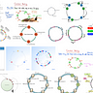](https://medium.com/@eddiebarth/list/general-coding-knowledge-f2d429d4f0cd?source=read_next_recirc-----52e12a62a259--------------------------------)](https://medium.com/@eddiebarth/list/general-coding-knowledge-f2d429d4f0cd?source=read_next_recirc-----52e12a62a259--------------------------------)

[[](https://medium.com/@eddiebarth/list/general-coding-knowledge-f2d429d4f0cd?source=read_next_recirc-----52e12a62a259--------------------------------)](https://medium.com/@eddiebarth/list/general-coding-knowledge-f2d429d4f0cd?source=read_next_recirc-----52e12a62a259--------------------------------)

[[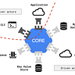](https://medium.com/@eddiebarth/list/general-coding-knowledge-f2d429d4f0cd?source=read_next_recirc-----52e12a62a259--------------------------------)](https://medium.com/@eddiebarth/list/general-coding-knowledge-f2d429d4f0cd?source=read_next_recirc-----52e12a62a259--------------------------------)

[General Coding Knowledge](https://medium.com/@eddiebarth/list/general-coding-knowledge-f2d429d4f0cd?source=read_next_recirc-----52e12a62a259--------------------------------)

[20 stories·297 saves](https://medium.com/@eddiebarth/list/general-coding-knowledge-f2d429d4f0cd?source=read_next_recirc-----52e12a62a259--------------------------------)

[[](https://medium.com/@jscribes/list/coding-development-e360d380bb82?source=read_next_recirc-----52e12a62a259--------------------------------)](https://medium.com/@jscribes/list/coding-development-e360d380bb82?source=read_next_recirc-----52e12a62a259--------------------------------)

[[](https://medium.com/@jscribes/list/coding-development-e360d380bb82?source=read_next_recirc-----52e12a62a259--------------------------------)](https://medium.com/@jscribes/list/coding-development-e360d380bb82?source=read_next_recirc-----52e12a62a259--------------------------------)

[[](https://medium.com/@jscribes/list/coding-development-e360d380bb82?source=read_next_recirc-----52e12a62a259--------------------------------)](https://medium.com/@jscribes/list/coding-development-e360d380bb82?source=read_next_recirc-----52e12a62a259--------------------------------)

[Coding & Development](https://medium.com/@jscribes/list/coding-development-e360d380bb82?source=read_next_recirc-----52e12a62a259--------------------------------)

[11 stories·150 saves](https://medium.com/@jscribes/list/coding-development-e360d380bb82?source=read_next_recirc-----52e12a62a259--------------------------------)

[[](https://medium.com/@wearedelicious/list/tech-tools-541154dfb3ae?source=read_next_recirc-----52e12a62a259--------------------------------)](https://medium.com/@wearedelicious/list/tech-tools-541154dfb3ae?source=read_next_recirc-----52e12a62a259--------------------------------)

[[](https://medium.com/@wearedelicious/list/tech-tools-541154dfb3ae?source=read_next_recirc-----52e12a62a259--------------------------------)](https://medium.com/@wearedelicious/list/tech-tools-541154dfb3ae?source=read_next_recirc-----52e12a62a259--------------------------------)

[[](https://medium.com/@wearedelicious/list/tech-tools-541154dfb3ae?source=read_next_recirc-----52e12a62a259--------------------------------)](https://medium.com/@wearedelicious/list/tech-tools-541154dfb3ae?source=read_next_recirc-----52e12a62a259--------------------------------)

[Tech & Tools](https://medium.com/@wearedelicious/list/tech-tools-541154dfb3ae?source=read_next_recirc-----52e12a62a259--------------------------------)

[15 stories·33 saves](https://medium.com/@wearedelicious/list/tech-tools-541154dfb3ae?source=read_next_recirc-----52e12a62a259--------------------------------)

[[](https://medium.com/@MediumStaff/list/stories-to-help-you-grow-as-a-software-developer-b1d913188c20?source=read_next_recirc-----52e12a62a259--------------------------------)](https://medium.com/@MediumStaff/list/stories-to-help-you-grow-as-a-software-developer-b1d913188c20?source=read_next_recirc-----52e12a62a259--------------------------------)

[[](https://medium.com/@MediumStaff/list/stories-to-help-you-grow-as-a-software-developer-b1d913188c20?source=read_next_recirc-----52e12a62a259--------------------------------)](https://medium.com/@MediumStaff/list/stories-to-help-you-grow-as-a-software-developer-b1d913188c20?source=read_next_recirc-----52e12a62a259--------------------------------)

[Stories to Help You Grow as a Software Developer](https://medium.com/@MediumStaff/list/stories-to-help-you-grow-as-a-software-developer-b1d913188c20?source=read_next_recirc-----52e12a62a259--------------------------------)

[19 stories·340 saves](https://medium.com/@MediumStaff/list/stories-to-help-you-grow-as-a-software-developer-b1d913188c20?source=read_next_recirc-----52e12a62a259--------------------------------)

[[](https://medium.com/@darshana_18428/steps-to-install-ssl-on-an-aws-ec2-instance-with-node-js-a0d26b04692d?source=read_next_recirc-----52e12a62a259----0---------------------3b6a993b_eb56_495d_9aad_f6b7fda8f160-------)](https://medium.com/@darshana_18428/steps-to-install-ssl-on-an-aws-ec2-instance-with-node-js-a0d26b04692d?source=read_next_recirc-----52e12a62a259----0---------------------3b6a993b_eb56_495d_9aad_f6b7fda8f160-------)

[[Darshana Mallick](https://medium.com/@darshana_18428?source=read_next_recirc-----52e12a62a259----0---------------------3b6a993b_eb56_495d_9aad_f6b7fda8f160-------)](https://medium.com/@darshana_18428?source=read_next_recirc-----52e12a62a259----0---------------------3b6a993b_eb56_495d_9aad_f6b7fda8f160-------)

[Darshana Mallick](https://medium.com/@darshana_18428?source=read_next_recirc-----52e12a62a259----0---------------------3b6a993b_eb56_495d_9aad_f6b7fda8f160-------)

**[Steps to install SSL on an AWS EC2 instance with Node.js](https://medium.com/@darshana_18428/steps-to-install-ssl-on-an-aws-ec2-instance-with-node-js-a0d26b04692d?source=read_next_recirc-----52e12a62a259----0---------------------3b6a993b_eb56_495d_9aad_f6b7fda8f160-------)**

[This article provides a comprehensive guide to configuring a Node.js HTTPS server on an AWS EC2 instance with an SSL certificate. By…](https://medium.com/@darshana_18428/steps-to-install-ssl-on-an-aws-ec2-instance-with-node-js-a0d26b04692d?source=read_next_recirc-----52e12a62a259----0---------------------3b6a993b_eb56_495d_9aad_f6b7fda8f160-------)

[5 min read·Jun 12](https://medium.com/@darshana_18428/steps-to-install-ssl-on-an-aws-ec2-instance-with-node-js-a0d26b04692d?source=read_next_recirc-----52e12a62a259----0---------------------3b6a993b_eb56_495d_9aad_f6b7fda8f160-------)

[[](https://medium.com/@elifront/best-next-js-docker-compose-hot-reload-production-ready-docker-setup-28a9125ba1dc?source=read_next_recirc-----52e12a62a259----1---------------------3b6a993b_eb56_495d_9aad_f6b7fda8f160-------)](https://medium.com/@elifront/best-next-js-docker-compose-hot-reload-production-ready-docker-setup-28a9125ba1dc?source=read_next_recirc-----52e12a62a259----1---------------------3b6a993b_eb56_495d_9aad_f6b7fda8f160-------)

[[Eli Front](https://medium.com/@elifront?source=read_next_recirc-----52e12a62a259----1---------------------3b6a993b_eb56_495d_9aad_f6b7fda8f160-------)](https://medium.com/@elifront?source=read_next_recirc-----52e12a62a259----1---------------------3b6a993b_eb56_495d_9aad_f6b7fda8f160-------)

[Eli Front](https://medium.com/@elifront?source=read_next_recirc-----52e12a62a259----1---------------------3b6a993b_eb56_495d_9aad_f6b7fda8f160-------)

**[Best Next.js docker-compose hot-reload production-ready Docker setup](https://medium.com/@elifront/best-next-js-docker-compose-hot-reload-production-ready-docker-setup-28a9125ba1dc?source=read_next_recirc-----52e12a62a259----1---------------------3b6a993b_eb56_495d_9aad_f6b7fda8f160-------)**

[As I was putting together my Dockerfile & docker-compose for my startup’s frontend, I found a lack of quality solutions that were both…](https://medium.com/@elifront/best-next-js-docker-compose-hot-reload-production-ready-docker-setup-28a9125ba1dc?source=read_next_recirc-----52e12a62a259----1---------------------3b6a993b_eb56_495d_9aad_f6b7fda8f160-------)

[6 min read·Jul 17](https://medium.com/@elifront/best-next-js-docker-compose-hot-reload-production-ready-docker-setup-28a9125ba1dc?source=read_next_recirc-----52e12a62a259----1---------------------3b6a993b_eb56_495d_9aad_f6b7fda8f160-------)

79

[1](https://medium.com/@elifront/best-next-js-docker-compose-hot-reload-production-ready-docker-setup-28a9125ba1dc?responsesOpen=true&sortBy=REVERSE_CHRON&source=read_next_recirc-----52e12a62a259----1---------------------3b6a993b_eb56_495d_9aad_f6b7fda8f160-------)

[[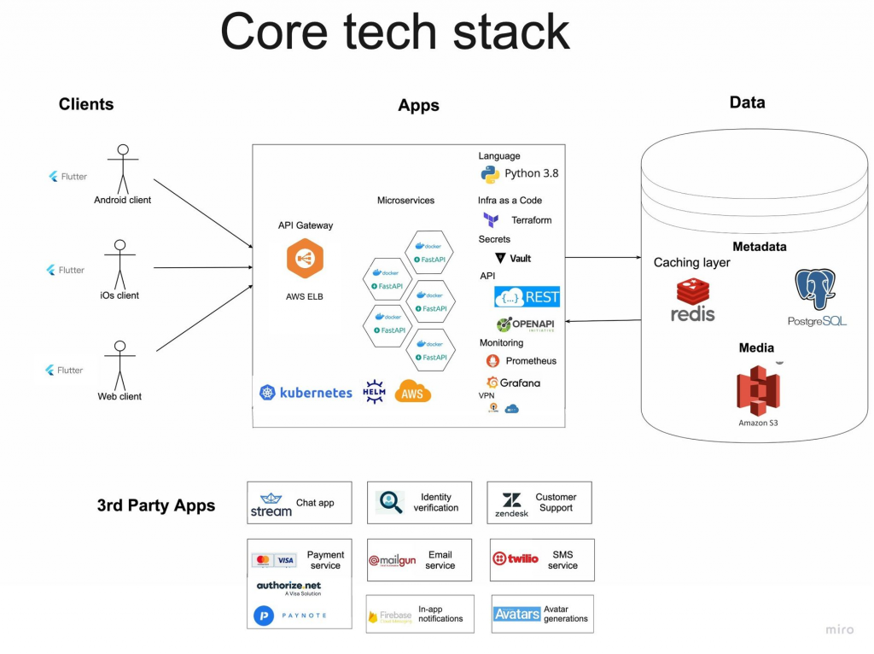](https://medium.com/better-programming/architecture-of-modern-startup-abaec235c2eb?source=read_next_recirc-----52e12a62a259----2---------------------3b6a993b_eb56_495d_9aad_f6b7fda8f160-------)](https://medium.com/better-programming/architecture-of-modern-startup-abaec235c2eb?source=read_next_recirc-----52e12a62a259----2---------------------3b6a993b_eb56_495d_9aad_f6b7fda8f160-------)

[[Dmitry Kruglov](https://medium.com/@kruglov.dmitry?source=read_next_recirc-----52e12a62a259----2---------------------3b6a993b_eb56_495d_9aad_f6b7fda8f160-------)](https://medium.com/@kruglov.dmitry?source=read_next_recirc-----52e12a62a259----2---------------------3b6a993b_eb56_495d_9aad_f6b7fda8f160-------)

[Dmitry Kruglov](https://medium.com/@kruglov.dmitry?source=read_next_recirc-----52e12a62a259----2---------------------3b6a993b_eb56_495d_9aad_f6b7fda8f160-------)

in

[Better Programming](https://medium.com/better-programming?source=read_next_recirc-----52e12a62a259----2---------------------3b6a993b_eb56_495d_9aad_f6b7fda8f160-------)

**[The Architecture of a Modern Startup](https://medium.com/better-programming/architecture-of-modern-startup-abaec235c2eb?source=read_next_recirc-----52e12a62a259----2---------------------3b6a993b_eb56_495d_9aad_f6b7fda8f160-------)**

[Hype wave, pragmatic evidence vs the need to move fast](https://medium.com/better-programming/architecture-of-modern-startup-abaec235c2eb?source=read_next_recirc-----52e12a62a259----2---------------------3b6a993b_eb56_495d_9aad_f6b7fda8f160-------)

[16 min read·Nov 7, 2022](https://medium.com/better-programming/architecture-of-modern-startup-abaec235c2eb?source=read_next_recirc-----52e12a62a259----2---------------------3b6a993b_eb56_495d_9aad_f6b7fda8f160-------)

5.5K

[48](https://medium.com/better-programming/architecture-of-modern-startup-abaec235c2eb?responsesOpen=true&sortBy=REVERSE_CHRON&source=read_next_recirc-----52e12a62a259----2---------------------3b6a993b_eb56_495d_9aad_f6b7fda8f160-------)

[[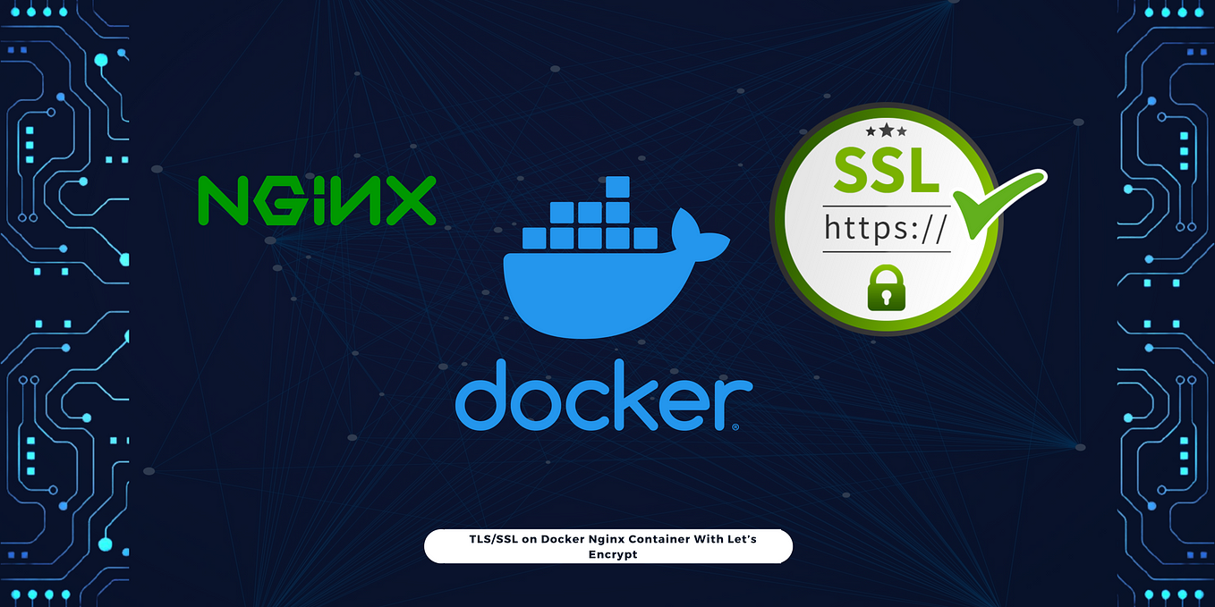](https://medium.com/@macdonaldchika/how-to-install-tls-ssl-on-docker-nginx-container-with-lets-encrypt-5bd3bad1fd48?source=read_next_recirc-----52e12a62a259----3---------------------3b6a993b_eb56_495d_9aad_f6b7fda8f160-------)](https://medium.com/@macdonaldchika/how-to-install-tls-ssl-on-docker-nginx-container-with-lets-encrypt-5bd3bad1fd48?source=read_next_recirc-----52e12a62a259----3---------------------3b6a993b_eb56_495d_9aad_f6b7fda8f160-------)

[[Macdonald Chika](https://medium.com/@macdonaldchika?source=read_next_recirc-----52e12a62a259----3---------------------3b6a993b_eb56_495d_9aad_f6b7fda8f160-------)](https://medium.com/@macdonaldchika?source=read_next_recirc-----52e12a62a259----3---------------------3b6a993b_eb56_495d_9aad_f6b7fda8f160-------)

[Macdonald Chika](https://medium.com/@macdonaldchika?source=read_next_recirc-----52e12a62a259----3---------------------3b6a993b_eb56_495d_9aad_f6b7fda8f160-------)

**[How To Install TLS/SSL on Docker Nginx Container With Let’s Encrypt](https://medium.com/@macdonaldchika/how-to-install-tls-ssl-on-docker-nginx-container-with-lets-encrypt-5bd3bad1fd48?source=read_next_recirc-----52e12a62a259----3---------------------3b6a993b_eb56_495d_9aad_f6b7fda8f160-------)**

[Discover how to secure your Nginx Docker container by leveraging Let’s Encrypt and Certbot.](https://medium.com/@macdonaldchika/how-to-install-tls-ssl-on-docker-nginx-container-with-lets-encrypt-5bd3bad1fd48?source=read_next_recirc-----52e12a62a259----3---------------------3b6a993b_eb56_495d_9aad_f6b7fda8f160-------)

[5 min read·Jun 10](https://medium.com/@macdonaldchika/how-to-install-tls-ssl-on-docker-nginx-container-with-lets-encrypt-5bd3bad1fd48?source=read_next_recirc-----52e12a62a259----3---------------------3b6a993b_eb56_495d_9aad_f6b7fda8f160-------)

31

[See more recommendations](https://medium.com/?source=post_page-----52e12a62a259--------------------------------)

[Help](https://help.medium.com/hc/en-us?source=post_page-----52e12a62a259--------------------------------)

[Status](https://medium.statuspage.io/?source=post_page-----52e12a62a259--------------------------------)

[Writers](https://about.medium.com/creators/?source=post_page-----52e12a62a259--------------------------------)

[Blog](https://blog.medium.com/?source=post_page-----52e12a62a259--------------------------------)

[Careers](https://medium.com/jobs-at-medium/work-at-medium-959d1a85284e?source=post_page-----52e12a62a259--------------------------------)

[Privacy](https://policy.medium.com/medium-privacy-policy-f03bf92035c9?source=post_page-----52e12a62a259--------------------------------)

[Terms](https://policy.medium.com/medium-terms-of-service-9db0094a1e0f?source=post_page-----52e12a62a259--------------------------------)

[About](https://medium.com/about?autoplay=1&source=post_page-----52e12a62a259--------------------------------)

[Text to speech](https://speechify.com/medium?source=post_page-----52e12a62a259--------------------------------)

[Teams](https://medium.com/business?source=post_page-----52e12a62a259--------------------------------)